Assignment – 1

Ques -1 Creating sample tables and inserting values.
Create the following tables with the given
structures and insert sample data as specified: -

A) SALESPEOPLE
Snum
Sname
City
Commint(4)
varchar(10)
varchar(10)
float(3,2)

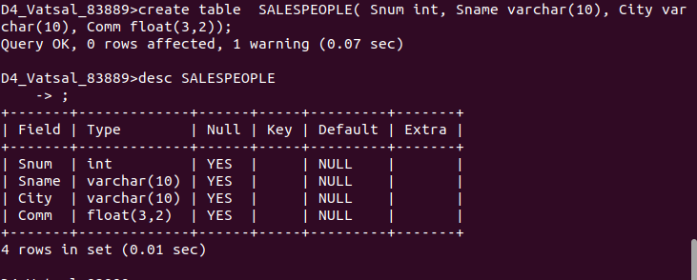

B) CUSTOMERS
Cnum
Cname
City
Rating
Snumint(4)
varchar(10)
varchar(10)
int(4)
int(4)

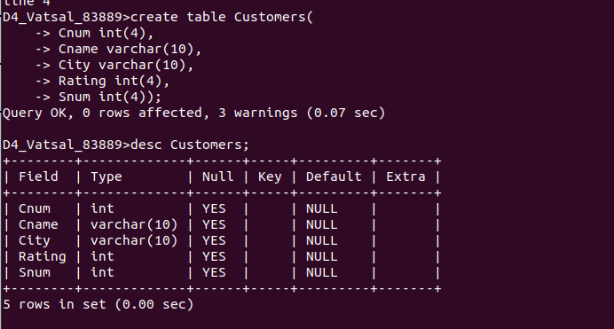

C) ORDERS
Onum
Amt
Odate
Cnum
Snum
int(4)
float(7,2)
date
int(4)
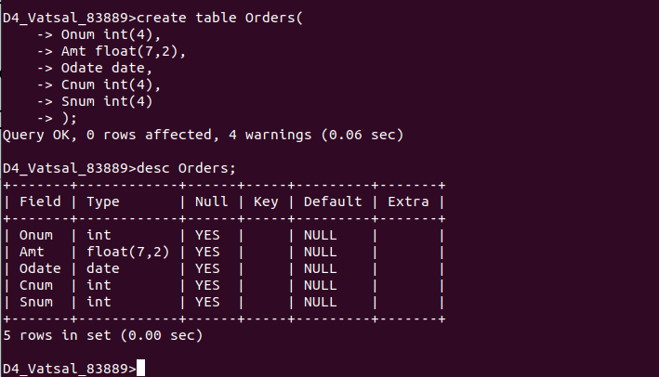
int(4)

